**May 2017 SL P1**

**Section A**

1. Describe the use of beta testing. [2]

It is when an application/program is tested/ to get feedback (for errors/improvements);

By releasing it to the general public/users/stakeholders before final release;

1. Identify **two** causes of data loss. [2]

Award up to ***[2 max]****.*

Natural disaster/power failure;

Accidental deletion;

Malicious activities (hacking/theft/viruses);

Hardware/software/system failure;

Bad integration/migration of systems/data;

Transmission error;

Lossy compression when the original no longer available only the modified version;

1. Identify **two** reasons for releasing a software update. [2]

*Award up to* ***[2 max]****.*

To patch any vulnerabilities/bugs/cyberspace threats;

To provide improved functionality/new functions/usability/maximize efficiencies;

To generate income for the software company/to innovate and stay ahead of other software companies;

To ensure compatibility with other (updated) technologies;

1. Explain why cache memory can speed up the processing within a computer. [2]

Cache memory can be accessed/is faster than RAM;

It is used to hold common/expected/frequently used data/operations;

Closer to CPU than RAM/situated between RAM and CPU/on same board as CPU/ with faster read/write speed;

Cache memory is static RAM and this memory doesn't need to be constantly refreshed;

1. One of the functions of an operating system is memory management.  
     
   Describe how this function prevents the system from crashing when more than one program is   
   run at the same time. [2]

The OS allocates (and deallocates) specific sections of memory to each

program/process/module;

This ensures that the memory assigned to one program is not overwritten;

Uses secondary/virtual memory to allow more processes to run simultaneously;

(**Note**: *Do not accept vague reasons*).

1. Identify any **two** of the layers of the OSI model. [2]

*Award up to* ***[2 max]*** *for any two of the following:*Physical layer;

Data link layer;

Network layer;

Transport layer;

Session layer;

Presentation layer;

Application layer;

1. Explain how compression of data may lead to negative consequences. [3]

Some compression methods (lossy) discard data;

Decompression will not return the complete file/some detail will have been removed;

Which in some cases e.g. audio/video may be unacceptable;

If original not saved/lost there is no way to recover it;

1. Explain how the use of media access control (MAC) addresses can improve security. [3]

*Award up to* ***[3 max]****.*

The MAC address identifies a specific device (network card/controller); MAC address checked against list of approved addresses/whitelist If not on list access to network is denied;

Prevents unauthorized access/makes access more difficult/(unless the NIC is cloned)/providing an extra layer to authentication process;

data sent to a specific MAC address can only be accessed on that device;

1. Outline the main steps involved in a selection sort. [3]

The list is searched for the next element in order;

And placed in its correct position in the new list deleting original **OR** in the same list by swapping with the element that was there;

This is repeated for all elements;

***Note: The sorted list may be constructed by swapping positions in the origin list or by putting in the element in the correct position in a separate list and deleting from the unsorted list.***

1. Other than the use of different keywords, outline two ways in which two higher level   
   languages might differ from one another. [4]

*Award* ***[1]*** *for identifying a way in which a higher-level language may differ from another*

*and* ***[1]*** *for developing that difference, up to* ***[2 max]****.*

*Mark as 2 and 2*

Method of translation;

Whether by compiler or interpreter (or both);

Loosely/strongly typed;

Refers to whether data types are specified;

Different programming paradigms;

Procedural or object oriented etc.;

Purpose of the language;

Specific (*eg* scientific/AI) or general;

Compatibility with different environments;

Java with virtual machine can run on all O/S / some languages are O/S specific;

Syntax differences;

Structure of statements *etc*;

**Note**: *Accept other reasonable answers*

**Section B**

1. A large company has taken over another business. This takeover has required various

changes to be made. One of the changes requires data migration.

1. (i) Define the term data migration. [1]  
     
     
     
     
     
   (ii) Describe **two** problems, concerning data migration, which the company may  
    have to overcome. [4]

*Award* ***[1]*** *for identifying a problem that may arise and* ***[1]*** *for an expansion / elaboration up to* ***[2 max].***

*Mark as 2 and 2*

Data loss;

Due to transmission faults/lack of adequate storage;

Incompatible file formats;

Which could lead to incomplete or incorrect data transfer;

Different file structures;

Which will result in a mismatch of data, for example in customer records;

Validation rules differ between companies;

Which could lead to inconsistent/incorrect results;

Different character sets might be used;

Which could lead to inconsistent/incorrect results;

Different languages might be used;

Leading to translation issues;

Data corrupted when transferring (data) files;

And not usable at destination; **[4]**

***Note:*** *Accept data loss as an issue unless the expansion is a repeat of the second issue identified.*

Data migration is the transfer of data from one system/storage device to another;

(Importing the data/database from the company to the company system)

1. Other than data migration, describe two aspects of change management that may arise

from this takeover. [4]

*Award* ***[1]*** *for identifying each aspect of change management that may arise and* ***[1]*** *for*

*an expansion / elaboration up to* ***[2 max]****.*

*Mark as 2 and 2*

Workforce issues;

Such as redundancy/retraining;

The time frame involved;

In merging the two systems;

Testing;

Of the combined systems/new data;

Data entry;

If migration not possible;

Costs involved;

In the aligning of the two systems;

Changeover decisions;

Such as parallel running *etc*;

The company produces industrial chemicals. One of the chemical processes is represented  
 by the following logic diagram.

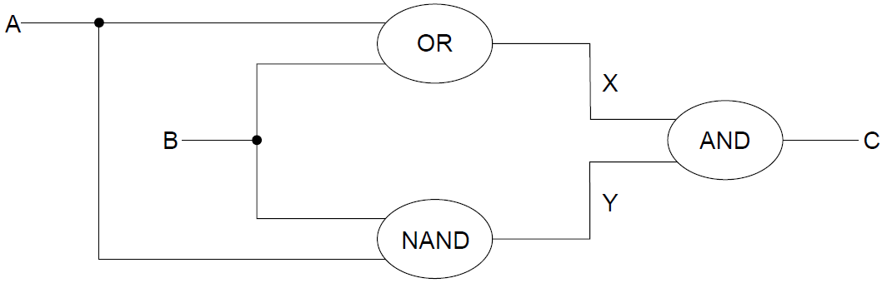

1. (i) Construct the truth table corresponding to this diagram. [3]

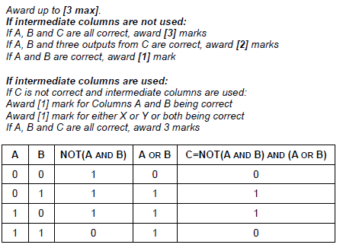

(ii) Identify the single logic gate that is equivalent to this diagram. [1]

XOR gate;

Note: *Follow through from an incorrect truth table in part (c)(i).*

*Accept A XOR B* = C

1. Outline how truth tables can be used to test that any two logic diagrams are equivalent. [2]

Two truth tables can be compared;

The same outputs from the same inputs, the circuits are equivalent;

1. 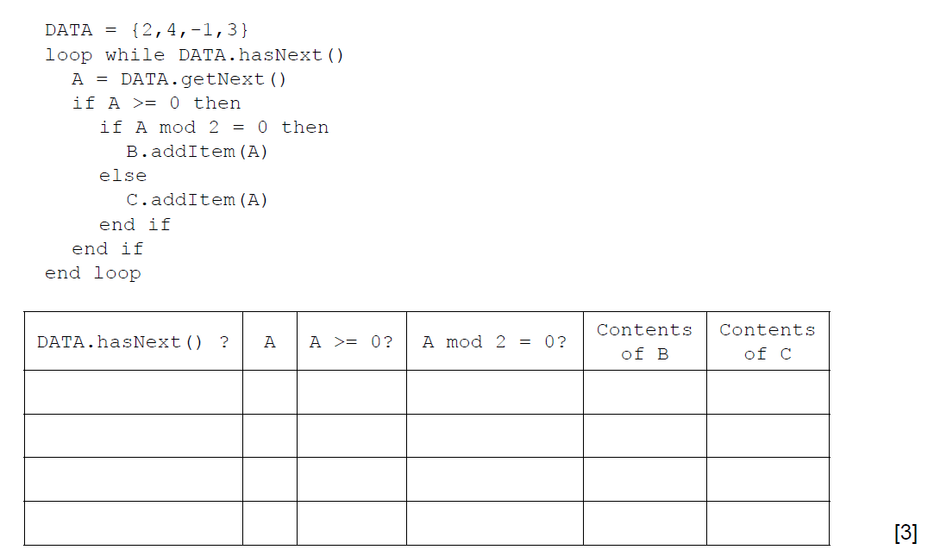 (a) By copying the table below, trace the following algorithm using the data in   
    the collection DATA. Note: B and C are also collections and are initially empty.

Award [***1]*** *mark if evident from the trace table that the loop executes exactly 4 times*

***[1]*** *mark for correct contents of B (2 and 4)*

***[1]*** *mark for the correct contents of C*

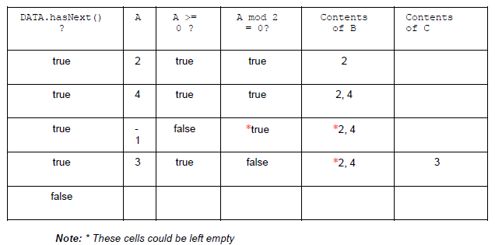

1. Outline the steps involved in performing a binary search on an array of ascending numbers.   
   **Note**: you can assume that the search value is present in the array and that initially LOW is   
   the index of the first value in the array and HI is the index of the last value. [4]

*Award* ***[4]*** *marks as follows:*

A position/index of the middle value calculated from HI and LOW;

If search value equals to value in the array at this position, then end;

Otherwise, change HI or LOW according to whether search value is above or below;

Repeat the process until search value is found;

*Example answer 1:*

1. Calculate MID (the midpoint of LOW and HI)

2. If ARRAY[MID] is the search value, end, else

3. If search value < than ARRAY[MID], HI = MID-1, else LOW = MID+1

4. Repeat steps 1, 2 and 3 until found

*Example answer 2*:

Find/calculate the midpoint/median value between HI and LOW;

If the array value at midpoint equals the search value; then the search value

is found;

If search value is greater than the array value at midpoint, set the midpoint as a new LOW and repeat the process - if search value is less than the array value at midpoint, set midpoint as a new HI;

Repeat until search value is found;

1. A collection called NUMBERS is to be searched to see if it contains a specified value.   
   Construct an algorithm in pseudocode to perform the following:

* input the number, S, to be searched for
* read in the values from the NUMBERS collection into the array D.   
  **Note**: you can assume that the array is large enough and that the collection is **not** empty
* perform a linear search for S on the array D
* output the message “found” or “not found” as appropriate. [5]

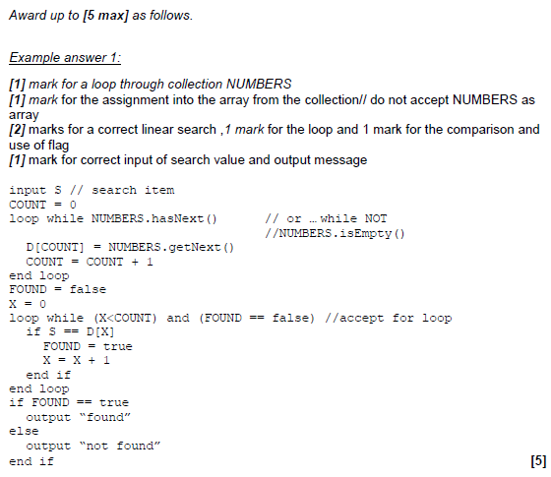

A binary search can be performed on the array D, if the values in D are in ascending order.  
 As the values are being read from NUMBERS into D they are checked to see if they are in order.

1. Without writing pseudocode, suggest how this check could be performed. [3]

*Award up to* ***[3 max]****.*

***[1]*** *mark for setting and changing a flag*

***[1]*** *mark for starting from the 2nd entry and checking all values as being entered*

***[1]*** *mark for comparing the current value with the previous one*

***Note****: Do not accept pseudocode/code.*

1. A multinational business requires secure communication between its offices in different countries. The business’s salesforce also needs secure remote access, as they travel the world.
2. (i) Identify **two** different types of network that can be combined to use the internet

to address the above requirements. [2]

WAN/GAN (global area network)

VPN;

Do not accept LAN or MAN or VLAN

(ii) For **one** of the networks identified in part (a)(i), describe the security   
 characteristics that are particular to this network. [3]

*Award* ***[3 max]*** *for one of the networks:*

(WAN/GAN)

A secure authentication process;

That involves login, passwords and security questions *(response should include at least two of these)*;

One-time pads;

Encryption;

(VPN)

Authentication;

Tunnelling;

Which is a packet within a packet;

(Each layer) encrypted;

Location and IP of user masked;

Give follow through for wrong answer in (i) including answers of wireless/cabled

Packet switching is used for sending data over the internet.

1. Discuss the importance of protocols in ensuring the successful preparation,   
   transmission and delivery of data using packet switching. [6]

*Award marks as follows:*

***[2]*** *marks for a clear understanding of protocols and packet switching*

***[2]*** *marks for explaining the importance of protocols in construction of packets/standard packet format with examples of information included in each packet*

***[2]*** *marks for a discussion of the role of protocols in the routing of packets to their destination*

*For example:*

Packet switching involves splitting data into packets to transmit to a specific destination;

Protocols are rules/standards used to compile and transmit each packet in a standard format;

Essential that all packets are constructed exactly the same;

So that the receiver knows automatically how to decode the contents/does not need further instructions for decoding the packets;

Error checking methods included to verify that data arrives in same state as it was sent;

Protocols include destination information that means that at each node the packet passes through it is sent to the next node towards the correct destination;

Packet number essential to be included for reassembling at the other end as not all packets will arrive in order;

***Note:*** *Construction and transmission will not necessarily be separated but it should*

*be clear that protocols are used to construct packets for successful transmission. Accept valid alternatives.*

1. Describe **two** advantages to society of the increased availability of WiFi outside the   
   home. [4]

*Award* ***[1]*** *for identifying a use of WIFI in public places and* ***[1]*** *for expanding the advantage, up to* ***[2 max]****.*

*Mark 2 and 2*

**Social:**

Keeping up to date when away from home/abroad/travelling/in hospital;

Can gain access to information such as email/social sites/sports results/ facetime family and friends from long distance/get your homework to do in cafe;

**Business:**

Working away from home (if you work from home);

Avoids missing important meetings if not present or travelling and not able to attend a meeting/ makes possible to work on documents;

**Immediate information:**

Access to public facilities; Make immediate payments/check local transport timetables/taxi (uber)/book restaurants;

**Cost saving:**

Convenience of mobile accessibility;

Without the cost incurring using a mobile network such as 3G/4G;

***Note:*** *Answers do not have to come from these categories but they should be used as a guide to avoid giving credit to repetitions.*